**NAAN MUDHALVAN**

**PROJECT REPORT ON**

WANDERLUST: A PERSONALIZED

TRAVEL PLANNING AND TRACKING APP

USING ANDROID STUDIO

**SUBMITTED BY TEAM NM_ID:**

**7A5578F7D3D51079258450078F2F34C1**

**TEAM LEADER: SUJITHA.G**

**TEAM MEMBERS:**

**SUDHARSHAN**

**SURYA PRAKASH**

**SURYA. M**

**INTRODUCTION:**

Wanderlust is a personalized travel planning and tracking app designed for Android devices. This app is designed to make it easier for travelers to plan their trips and keep track of their adventures, all in one convenient place.

With Wanderlust, users can easily search for flights, hotels, and activities based on their preferences and budget. The app also allows users to create personalized itineraries by adding their chosen activities and events to their schedule. Users can even share their itineraries with friends and family, making it easier to coordinate group trips.

In addition to travel planning, Wanderlust also serves as a travel journal, allowing users to document their experiences through photos, notes, and check-ins. The app's tracking feature helps users keep track of the places they've visited and the things they've done, making it easy to remember all the highlights of their trip.One of the unique features of Wanderlust is its ability to provide personalized recommendations based on the user's interests and previous travel experiences. The app uses machine learning algorithms to analyze the user's preferences and suggest activities and destinations that match their interests.

Overall, Wanderlust is a comprehensive travel planning and tracking app that can help travelers make the most of their trips. Whether users are planning a weekend getaway or a long-term adventure, this app can provide the tools and resources they need to make their travels memorable and hassle-free.

**ABOUT THE PROJECT:**

Wanderlust is a feature-rich travel app that has been designed to cater to the unique needs of modern-day travelers. The app is equipped with advanced algorithms that analyse user preferences and suggest the best travel options based on their interests, past trips, and budget. It offers a hassle-free travel planning experience by allowing users to book flights, hotels, and activities, all in one place.

The app's tracking feature is particularly useful for travelers who want to document their adventures and remember their experiences. Users can check-in to locations, take photos, and add notes, which can be shared with friends and family. The app also allows users to create custom itineraries and share them with others, making it easy to plan group trips.

Wanderlust's user interface is intuitive and easy to use. The app has been optimized for mobile devices, making it perfect for travelers who want to plan their trips on-the-go. The app's ability to provide personalized recommendations and travel options is a major advantage over other travel apps on the market.

Overall, Wanderlust is an ideal travel app for anyone looking to simplify their travel planning process and document their experiences. With its advanced features and user-friendly interface, Wanderlust makes it easy for travelers to plan their trips and enjoy their adventures to the fullest.

**PROBLEM DEFINITION:**

Wanderlust: A Personalized Travel Planning and Tracking App aims to solve the problem of complex and stressful travel planning and tracking. With so many travel options and details to consider, it can be overwhelming and time-consuming to plan and track a trip. This can lead to missed opportunities, forgotten details, and frustration. Wanderlust seeks to simplify the travel planning process by providing personalized recommendations for flights, hotels, and activities based on the user's interests and budget. It also allows users to track their itinerary, document their experiences, and share their adventures with friends and family. By addressing these pain points, Wanderlust aims to make travel planning and tracking more enjoyable and stress-free.

**DESIGN THINKING:**

The design thinking behind Wanderlust: A Personalized Travel Planning and Tracking App was focused on putting the user at the center of the design process. The design team empathized with the pain points and needs of modern travelers, conducted research to understand user behavior, and prototyped multiple versions of the app to test and refine the design. The team used a human-centered approach, combining user research, ideation, prototyping, and testing to create an app that is both functional and user-friendly. By prioritizing user needs and feedback, the Wanderlust team was able to design an app that provides a seamless and enjoyable travel planning and tracking experience for users.

**i)EMAPTHY MAP:**

Here's an empathy map for Wanderlust travel planning and tracking app with the "Says, Thinks, Does, and Feels" framework:

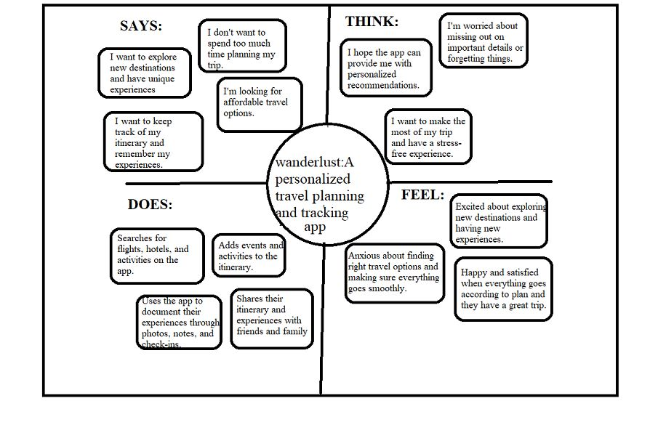**ii)IDEATION & BRAINSTORMING:**

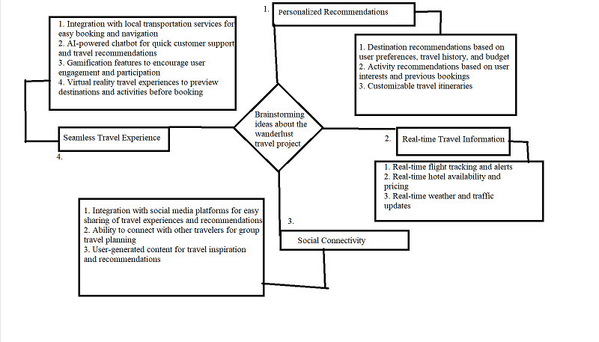

Here's an ideation and brainstorming map for Wanderlust travel planning and tracking app.

**PROJECT SCREENSHOTS AND DESCRIPTION**

1. Here, it is Register page:

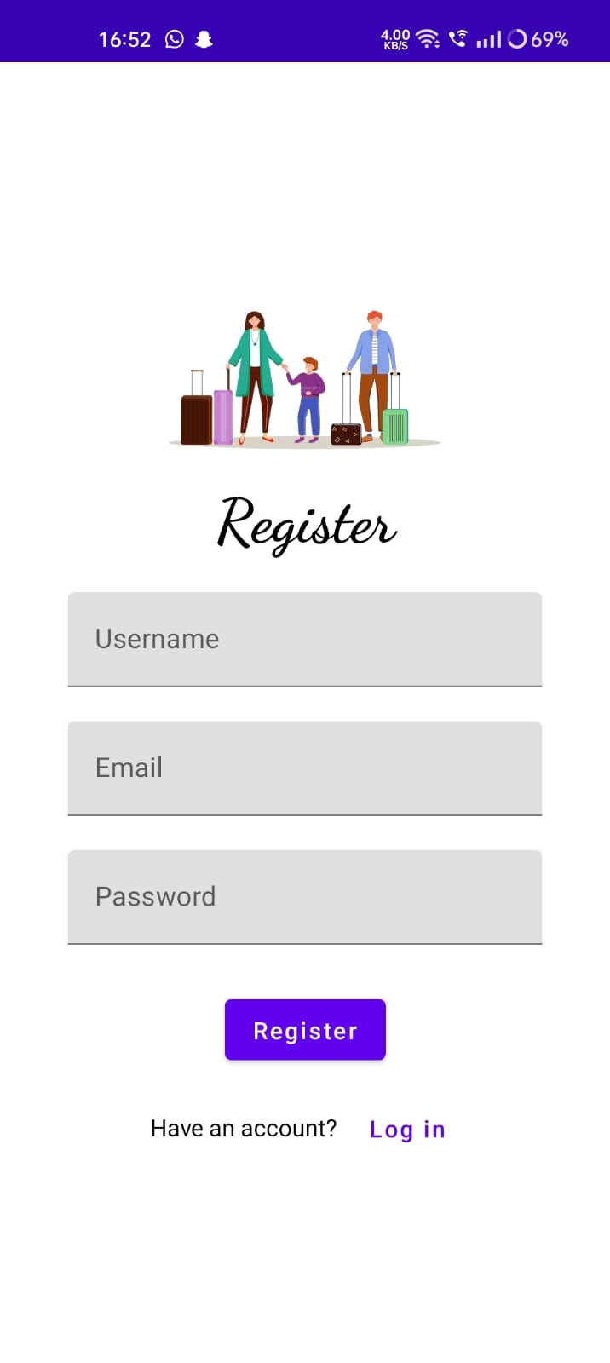

1. Here, it is login page:

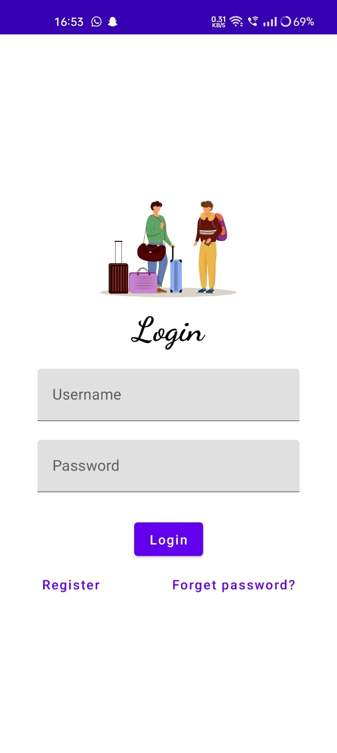

1. Here, it is home page:

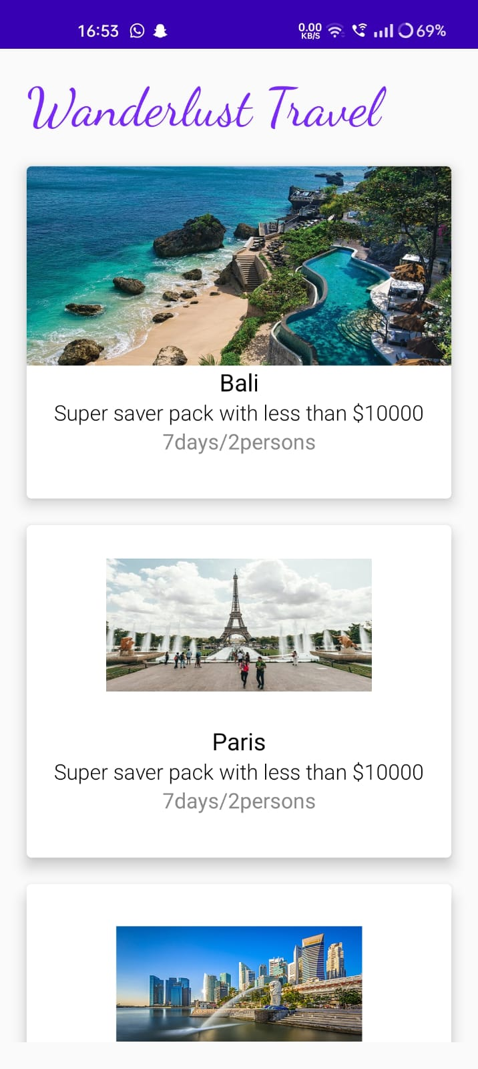

**DESCRIPTION:**

**Project Description:**

A project built using the Android Compose UI toolkit. It demonstrates how to create a simple travel app using the Compose libraries. It also features a personalized feed of recommended accommodations based on the locations.

**Architecture:**

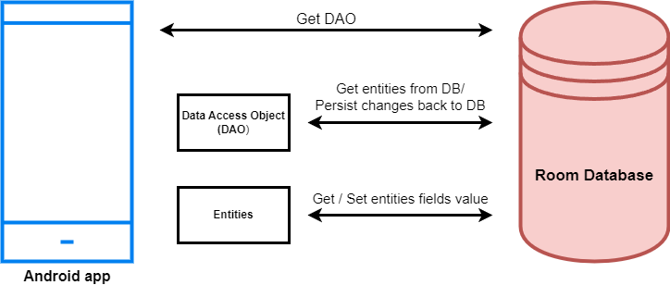

**Project Workflow:**Users register into the application.

* After registration , user logins into the application.
* User enters into the main page

**Tasks:**

1.Required initial steps

2.Creating a new project.

3.Adding required dependencies.

4.Creating the database classes.

5.Building application UI and connecting to database.

6.Using AndroidManifest.xml

7.Running the app

**TRAILHEAD PROFILE PUBLIC URL**

Team leaders: sujitha G

<https://trailblazer.me/id/sgopinath30>

Team member: sudharshan S S

<https://trailblazer.me/id/sudharshanss>

Team member: surya Prakash E

<https://trailblazer.me/id/surya2524>

Team member: surya M

<https://trailblazer.me/id/surym0001>

**PROJECT VIDEO LINK:**

[**https://drive.google.com/file/d/1Wun-I-9edbtdNiuzMs1-tvvBMeP2N1bS/view?usp=drivesdk**](https://drive.google.com/file/d/1Wun-I-9edbtdNiuzMs1-tvvBMeP2N1bS/view?usp=drivesdk)

**ADVANTAGES:**

1. Personalized recommendations based on user preferences.
2. Real-time travel information, alerts, and updates.
3. Seamless travel experience with local transportation integration and AI-powered chatbot.
4. Social connectivity for sharing experiences and user-generated content.
5. Virtual reality travel experiences for previewing destinations and activities.
6. Customizable travel itineraries tailored to individual preferences and schedules.
7. Cost savings through deals and discounts on flights, accommodations, and activities.
8. Time savings with streamlined travel planning and booking in one place.
9. Enhanced security features for safe and secure travel.
10. User-friendly design for easy navigation and accessibility to travelers of all backgrounds.

**DISADVANTAGES:**

1. The app may require frequent updates to function properly, which can be a nuisance for some users.
2. The app may require users to have a stable and reliable internet connection in order to use certain features, which can be a challenge for users traveling to areas with limited or no internet access.
3. The app may be difficult to use or navigate for users who are not tech-savvy or familiar with mobile apps.
4. The app may have limited or no offline functionality, which can be inconvenient for users who do not have internet access at all times.

**APPLICATIONS:**

1. Personal travel planning: The app can be used by individuals to plan and organize their own travel itineraries, including booking accommodations, creating trip schedules, and tracking expenses.
2. Group travel planning: The app can be used by groups of friends or family members to plan and coordinate group trips, including managing group expenses and scheduling activities.
3. Business travel planning: The app can be used by business travelers to plan and organize their travel schedules, including booking flights, hotels, and rental cars, and tracking expenses for reimbursement purposes.
4. Tourist industry: The app can be used by travel companies, tour operators, and travel agents to create customized travel packages for their clients, and to provide real-time updates and support to clients during their travels.
5. Travel blogging: The app can be used by travel bloggers to create and share travel itineraries, reviews, and recommendations with their audiences.
6. Educational travel: The app can be used by schools and universities to plan and organize educational trips for students, including managing logistics, booking accommodations, and scheduling educational activities.
7. Destination marketing: The app can be used by tourism boards and destination marketing organizations to promote their destinations and provide personalized travel recommendations to potential visitors.

**CONCLUSION:**

In conclusion, Wanderlust: A Personalized Travel Planning and Tracking App is a comprehensive solution for travelers who want to plan and track their trips effectively. The app offers personalized recommendations for destinations, accommodations, and activities based on users' preferences and travel history. It also allows users to create customized itineraries and track their expenses.

However, while the app has many advantages, there are also some disadvantages, such as the learning curve for new users and the potential for technical glitches. The app developers must address these limitations to improve the user experience.

Overall, Wanderlust: A Personalized Travel Planning and Tracking App is a valuable tool for travelers who want to make the most of their trips. With its user-friendly interface, personalized recommendations, and tracking features, the app helps users plan and execute their travels efficiently.